Slot Matching Puzzle

To create a Slot Matching Puzzle, three types of elements are needed:



**PuzzleSlotMatching** is the main element for the puzzle. It needs at least two children: a slot and an item that goes in that slot. However, any number of slots and items can be added (as long as there are enough items to be put in all the slots). The following script is attached to it:

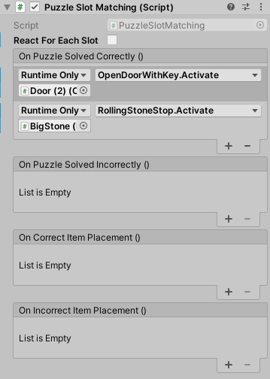

The puzzle can react each time an item is placed in a slot or when all slots have items. It can react when something is placed/solved correctly or when a mistake is made. The system is based on Unity Events.

**PuzzleSlot** needs a trigger collider and the PuzzleSlot script where you need to define the PuzzleItem ID for the item required in this slot.

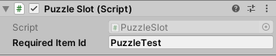

**PuzzleItem** also needs a trigger collider and the *Item* tag so the player can pick it up. It has a PuzzleItem script where you can define the sprite and the Item ID which has to match the *RequiredItemId* in PuzzleSlot.

